

**Activate SharePoint Online Migration**

**Scenario Guide 4.1**

Migrate SharePoint Server content to SharePoint Online



**Conditions and Terms of Use**

**Microsoft Confidential**

This training package is proprietary and confidential, and is intended only for uses described in the training materials. Content and software is provided to you under a Non-Disclosure Agreement and cannot be distributed. Copying or disclosing all or any portion of the content and/or software included in such packages is strictly prohibited.

The contents of this package are for informational and training purposes only and are provided "as is" without warranty of any kind, whether express or implied, including but not limited to the implied warranties of merchantability, fitness for a particular purpose, and non-infringement.

Training package content, including URLs and other Internet Web site references, is subject to change without notice. Because Microsoft must respond to changing market conditions, the content should not be interpreted to be a commitment on the part of Microsoft, and Microsoft cannot guarantee the accuracy of any information presented after the date of publication. Unless otherwise noted, the companies, organizations, products, domain names, e-mail addresses, logos, people, places, and events depicted herein are fictitious, and no association with any real company, organization, product, domain name, e-mail address, logo, person, place, or event is intended or should be inferred.

**Copyright and Trademarks**

© 2020 Microsoft Corporation. All rights reserved.

Microsoft may have patents, patent applications, trademarks, copyrights, or other intellectual property rights covering subject matter in this document. Except as expressly provided in written license agreement from Microsoft, the furnishing of this document does not give you any license to these patents, trademarks, copyrights, or other intellectual property.

Complying with all applicable copyright laws is the responsibility of the user. Without limiting the rights under copyright, no part of this document may be reproduced, stored in or introduced into a retrieval system, or transmitted in any form or by any means (electronic, mechanical, photocopying, recording, or otherwise), or for any purpose, without the express written permission of Microsoft Corporation.

For more information, see Use of Microsoft Copyrighted Content at

<http://www.microsoft.com/en-us/legal/intellectualproperty/Permissions/default.aspx>

DirectX, Hyper-V, Internet Explorer, Microsoft, Outlook, OneDrive, SQL Server, Windows, Microsoft Azure, Windows PowerShell, Windows Server, Windows Vista, and Zune are either registered trademarks or trademarks of Microsoft Corporation in the United States and/or other countries. Other Microsoft products mentioned herein may be either registered trademarks or trademarks of Microsoft Corporation in the United States and/or other countries. All other trademarks are property of their respective owners.

Contents

4.1 Migrate SharePoint Server content to SharePoint Online 5

**Objective** 5

**Scenario** 5

**Getting started** 5

Understanding the SharePoint modern experience 5

How to migrate from classic SharePoint Server sites to the modern experience 6

Prerequisites 7

**Start scenario** 8

4.1.1 Download and install SPMT 8

4.1.2 Use SPMT GUI to migrate content to SPO 9

4.1.3 Perform an incremental migration 19

4.1.4 Change configuration settings 22

Create a custom user mapping file 22

Start a new migration with modified settings 24

4.1.5 Enable modern experiences on the migrated sites 28

Register a migrated site as a hub site using the SharePoint Admin portal 28

Associate a migrated site to the new hub site using the SharePoint Admin Portal 29

Remove the hub site and association using the SharePoint Admin portal 29

Connect a migrated site to a new Microsoft 365 Group 29

4.1.6 Perform a bulk migration using a CSV file and the SPMT GUI 31

Prepare the source SharePoint Server site with sub folders and content 31

Create a CSV file for content migration 32

Use the SPMT tool to migrate content using a CSV file 33



## Migrate SharePoint Server content to SharePoint Online

## **Objective**

Learn about the modern experiences in SharePoint Online and how to transition from classic to modern experience as part of the migration to Microsoft 365.

## **Scenario**

You want to transition from classic sites in SharePoint Server to modern sites in SharePoint Online.

* Learn about the modern experiences in SharePoint Online and how to migrate from classic SharePoint Server sites to modern SharePoint Online sites.
* Migrate SharePoint Server content to SharePoint Online using the SharePoint Migration Tool.
* Perform an incremental migration.
* Perform batch migrations.
* Enable additional modern experiences post content migration.

## **Getting started**

Before migrating content from SharePoint Server to SharePoint Online, learn about the modern experiences in SharePoint Online and how you can transition from classic sites to modern experiences during the migration.

### Understanding the SharePoint modern experience

The Modern experience in SharePoint is designed to be compelling, flexible and more performant. The modern experience makes it easier for anyone to create beautiful, dynamic sites and pages that are mobile-ready. The modern experience includes new site templates (Communication and Modern Team Sites), modern libraries, modern publishing pages, Hub Sites, and integration with Microsoft 365 Groups and Microsoft Teams.

Classic SharePoint architecture is typically built using a hierarchical system of site collections and nested sub-sites, with inherited navigation, permissions, and site designs. Once built, this structure can be inflexible and difficult to maintain. In the modern SharePoint experience, every site is a site collection, and all can be associated with a hub site which is a flat structure of sites that share navigation, branding, and other elements. This type of structure is far more flexible and adaptive to the changing needs of your organization. Here is an example of a modern information architecture utilizing all site collections, modern site templates and hub sites:

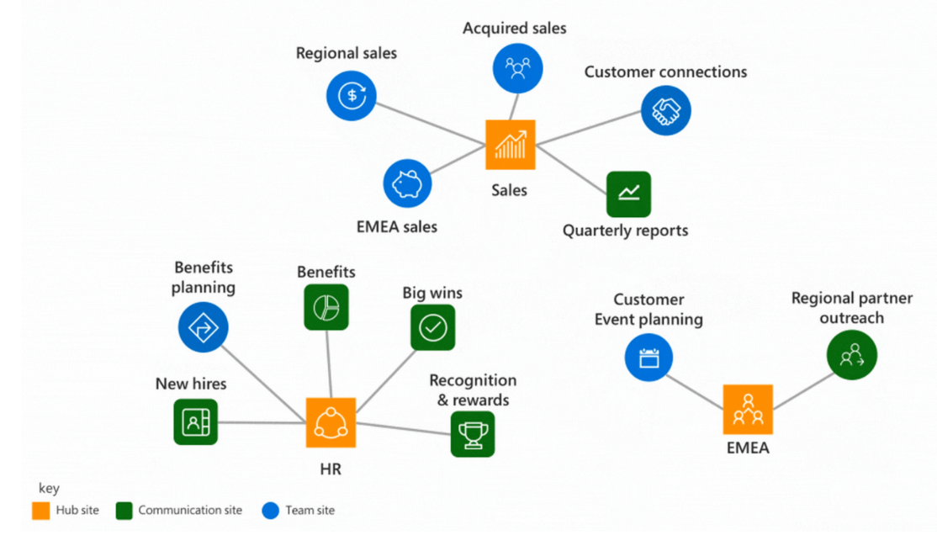

Source: Planning your SharePoint hub sites: <https://docs.microsoft.com/en-us/sharepoint/planning-hub-sites>

For more information about the modern experiences in SharePoint Online please review the following resources:

* [Guide to the SharePoint modern experience](https://docs.microsoft.com/en-us/sharepoint/guide-to-sharepoint-modern-experience)
* [Branding SharePoint sites in the modern experience](https://docs.microsoft.com/en-us/sharepoint/branding-sharepoint-online-sites-modern-experience)
* [Plan navigation in the modern experience](https://docs.microsoft.com/en-us/sharepoint/plan-navigation-modern-experience)
* [Learn about how to plan for Hub sites](https://docs.microsoft.com/en-us/sharepoint/planning-hub-sites).
* [Moving from Publishing sites to Communication sites](https://docs.microsoft.com/en-us/sharepoint/publishing-sites-classic-to-modern-experience)
* [Sharing and permissions in the SharePoint modern experience](https://docs.microsoft.com/en-us/sharepoint/sharing-permissions-modern-experience)

### How to migrate from classic SharePoint Server sites to the modern experience

Migration from classic sites in SharePoint Server to modern sites in SharePoint Online is the default experience when using the **SharePoint** **Migration** **Tool** (SPMT):

* Classic **team** sites are migrated to new modern team sites.
* Classic **publishing** sites are migrated to modern team sites with the publishing feature enabled.
* *What about communication sites?* Classic sites/content in SharePoint Server can also be migrated into a new communication site in SharePoint Online using SPMT, but the target communication site must be -pre-created first.

Once the content has been migrated to a modern team site you can connect it to a new **Microsoft** **365** **Group** then create a team in **Microsoft** **Teams** to unlock even more modern collaboration and real-time communication experiences spanning the entire suite of Microsoft 365.

The only way to preserve the classic experience when using SPMT is to pre-create a classic team site in SharePoint Online first, then use the SPMT tool to migrate content into the target classic site. It is strongly encouraged to avoid migrating into classic sites.

The following is an example of classic sites on SharePoint Server and how they could map to modern sites in Microsoft 365:

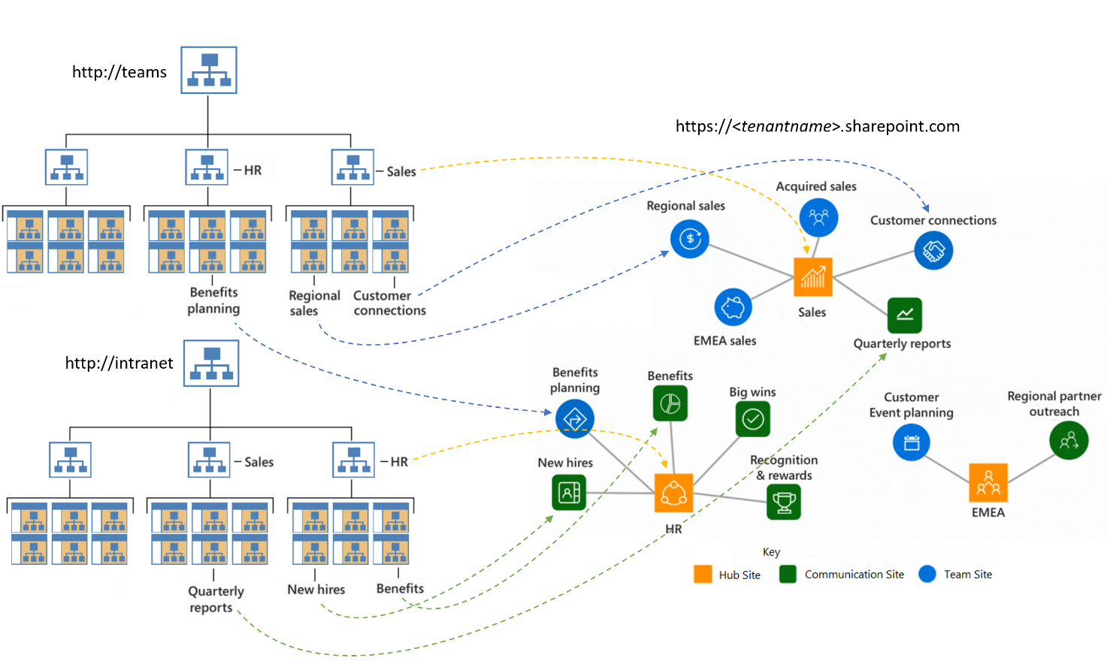

Plan on transitioning to modern experiences in Microsoft 365 and adopting a flattened information architecture as part of the overall migration process.

### Prerequisites

Identify a migration machine to install the SharePoint Migration Tool:

* The machine must meet the following software and hardware requirements:

|  |  |  |
| --- | --- | --- |
| **Component** | **Requirements for Best performance** | **Minimum requirements** (expect slow performance) |
| CPU | 64-bit quad core processor or better | 64-bit 1.4 GHz 2-core processor or better |
| RAM | 16 GB | 8 GB |
| Local Storage | Solid state disk: 150 GB free space | Hard disk: 150 GB free space |
| Network card | 1 Gbps | High-speed Internet connection |
| Operating system | Windows Server 2012 R2 or Windows 10 client .NET Framework 4.6.2 | Windows Server 2008 R2, Windows 7 updated or better .NET Framework 4.6.2 |
| Microsoft Visual C++ 2015 Redistributable | Required for OneNote migration. | Required for OneNote migration. |

Identify accounts that will be used to connect to the source and target sites:

* The account used to connect to the SharePoint Server site: **Site Collection Administrator**
* The account used to authenticate to SharePoint Online must have the **SharePoint** **Administrator** or **Global** **Administrator** roles to the target Microsoft 365 tenant.

Identify a SharePoint Server site to migrate to Microsoft 365 (or create a new site). The SharePoint Server site should meet the following requirements:

* The site must have at least **3 document libraries** each containing some content.
* The total size of the SharePoint Server site should be less than **1GB** so the migration can complete quickly.
* Record the **Title** and **URL** of the site.

## **Start scenario**

Follow the instructions below to complete the scenario:

### Download and install SPMT

Download and install the latest version of the SharePoint Migration Tool on the migration machine.

1. Open a browser and navigate to: <https://docs.microsoft.com/en-us/sharepointmigration/introducing-the-sharepoint-migration-tool>
2. Click the version to download.

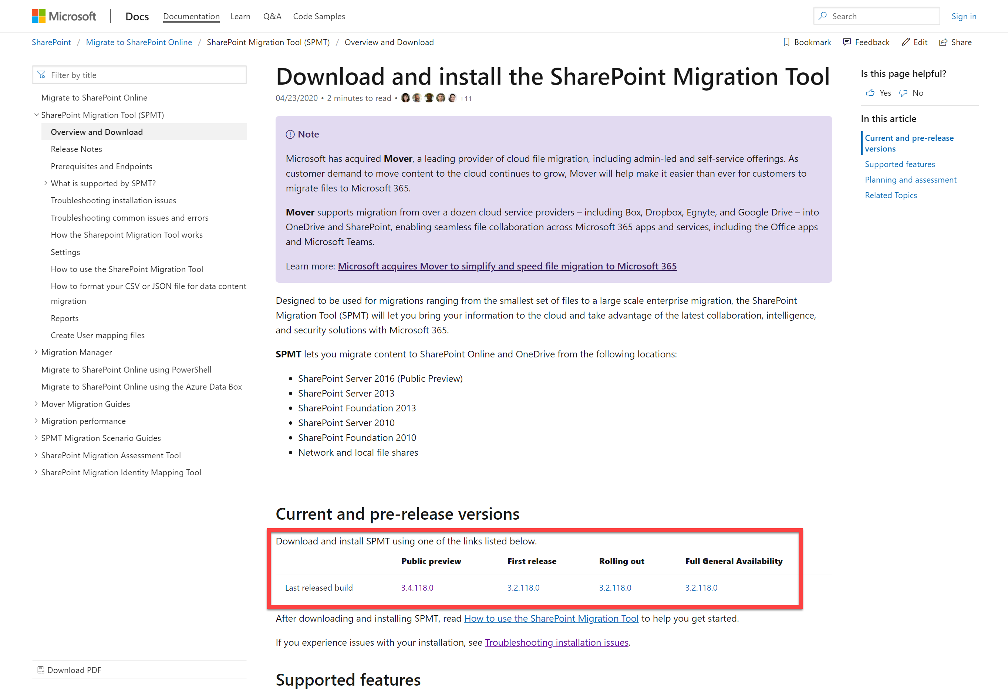

1. Review and accept the **Terms of Service** by checking the box and click **Install**.
2. Click **Run** when prompted to install the tool by the browser:



1. The SPMT tool automatically launches after installation.

### Use SPMT GUI to migrate content to SPO

Use the **SharePoint** **Migration** **tool** to migrate content from the SharePoint Server site to the connected SharePoint Online site.

1. Launch the **SharePoint Migration Tool** (if not already open from previous step).
2. On the **Sign in to your account** prompt, enter credentials of an account with **Global Administrator** or **SharePoint** **Administrator** roles to the target O365 tenant
3. If you see a **Welcome** **to** **the** **SharePoint** **Migration** **Tool** screen click **Start** **a new** **migration**

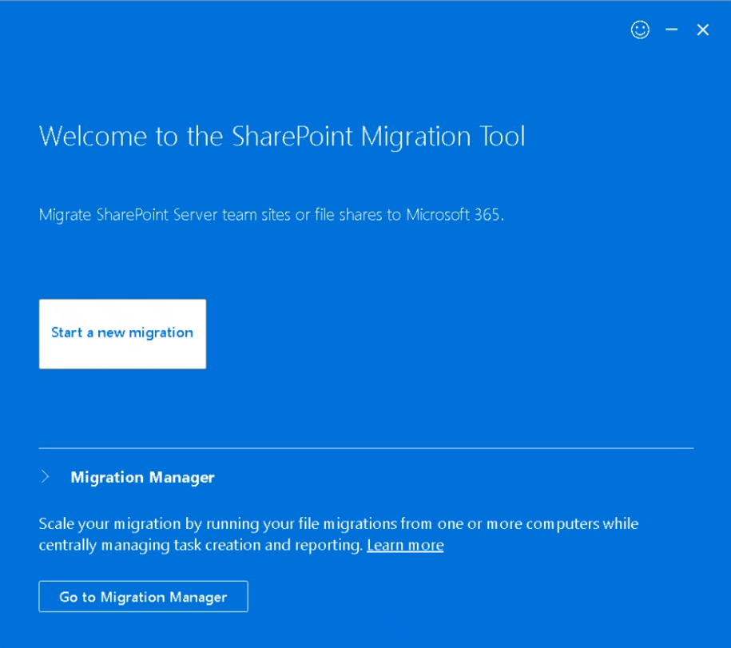

1. On the **Where’s your content** screen select **SharePoint Server**

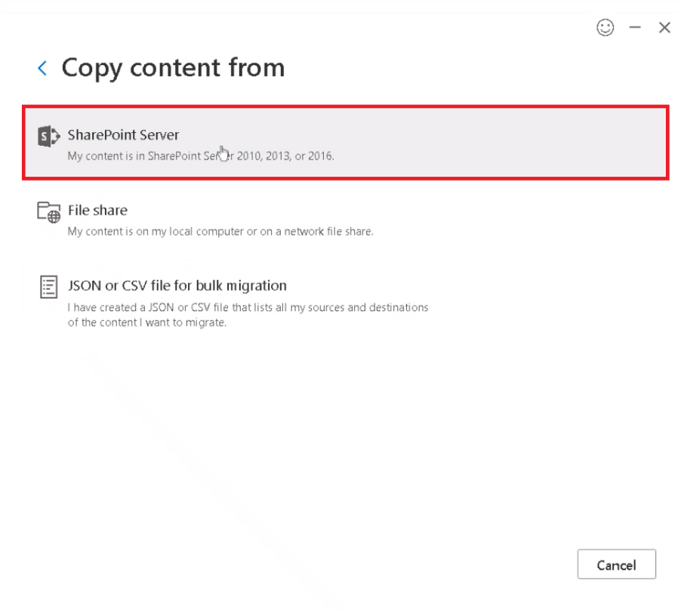

1. On the **Select a source** screen, enter the URL of the source site in the **What site contains the content** area and click outside the box to invoke the sign-in process.
2. On the **Sign-in to the site** **below** **to** **authenticate** prompt, enter the credentials of an account with **Site** **Collection** **Administrator** permissions to the site collection, then click **Sign in**.
3. Returning to the **Select** **a** **source** **screen**, check the box **Include** **all** **subsites** (if there are sub-sites), and in the **Select** **the** **content** **you** **wish** **to** **migrate** screen, select **Migrate** **all** **lists**, **libraries**, **pages** **and** **web** **parts** from the dropdown, then click **Next** to proceed.

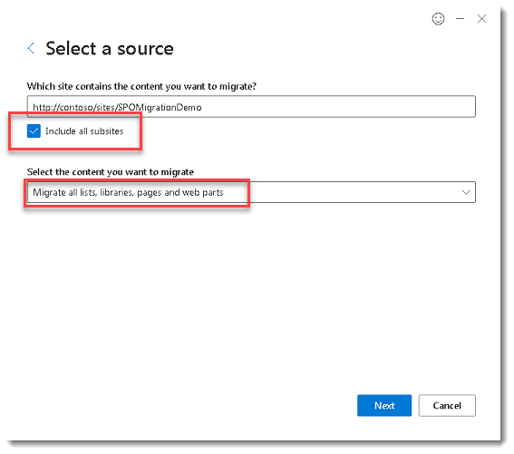

If prompted in the **Sign-in to the site below to authenticate** enter credentials of an account thathas access to the source SharePoint Server site.

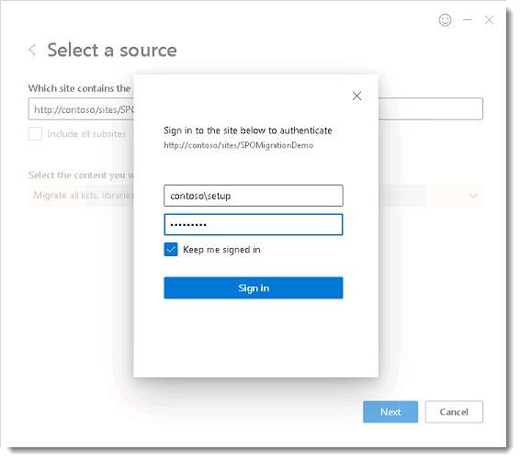

1. On the **Where do you want to move it to** screen select **SharePoint team Site.**

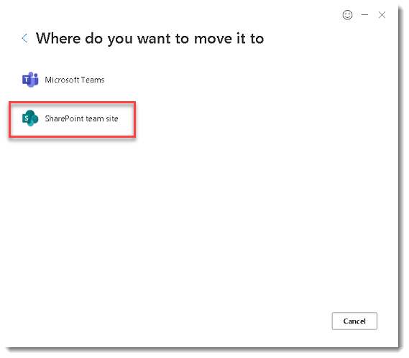

1. On the **Select** **a** **destination** screen enter the URL to the target SharePoint Online site that you obtained in the previous steps. Confirm you see the informational text: “**Your** **content** **will** **be** **moved** **to** **this** **site**.” Click **Next** to proceed.

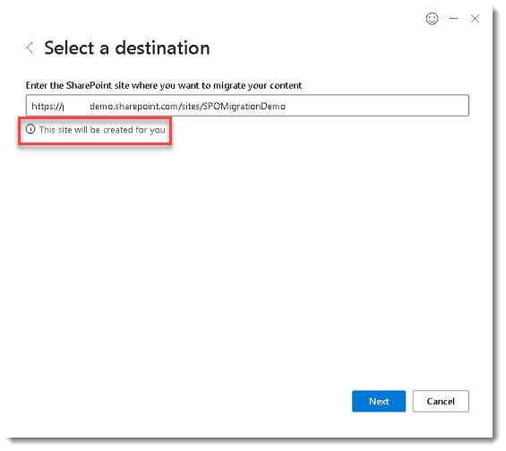

1. On the **Review** **migration** screen, in the **Name** **your** **migration** field enter a unique name for the migration (or leave the default name) and click **Next**.

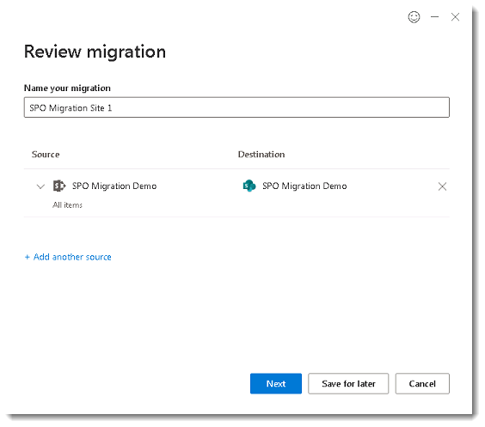

1. On the **choose** **your** **settings** click **View all settings**.

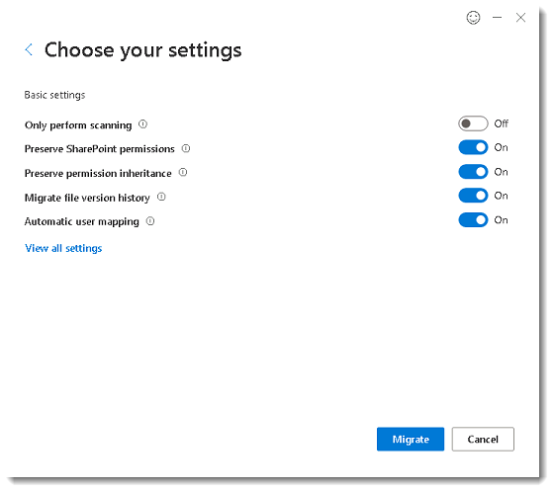

1. On the **All migration settings** screen review all the settings and discuss what the customer might want to enabled/disable.

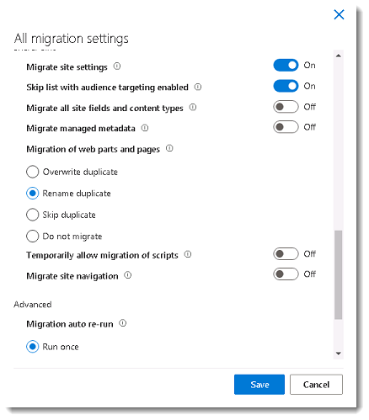

1. On the **Choose your settings** screen click **Migrate**.
2. Monitor the migration progress. Click **Migration** **Details** for more information.

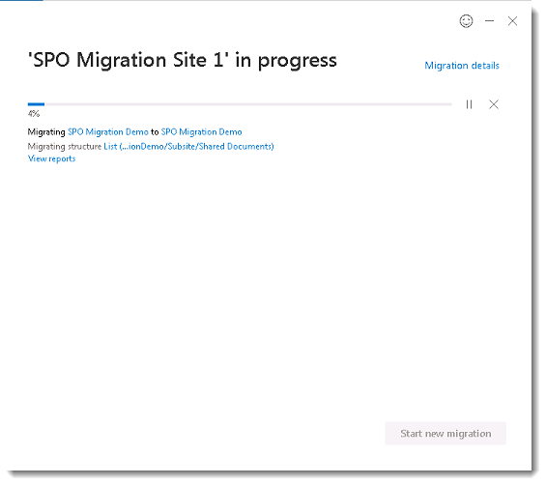

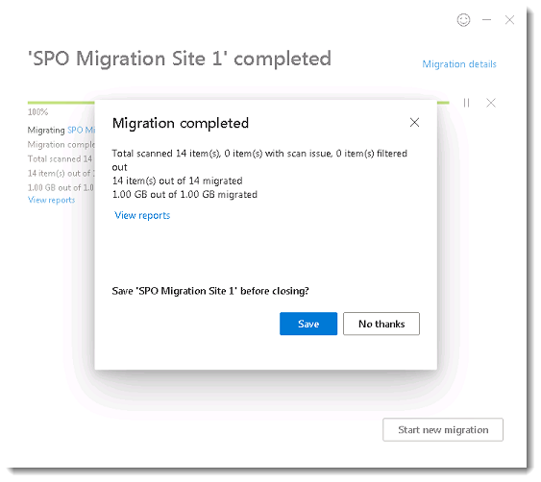

1. Click on the **View reports** link in the **progress** window (or in the **Migration** **completed** window). Review the reports to identify any errors that may have been encountered during the migration. In the **Migration** **completed** window click **Save**. Saving the site in the SharePoint Migration Tool allows you to perform an **incremental** migration later.

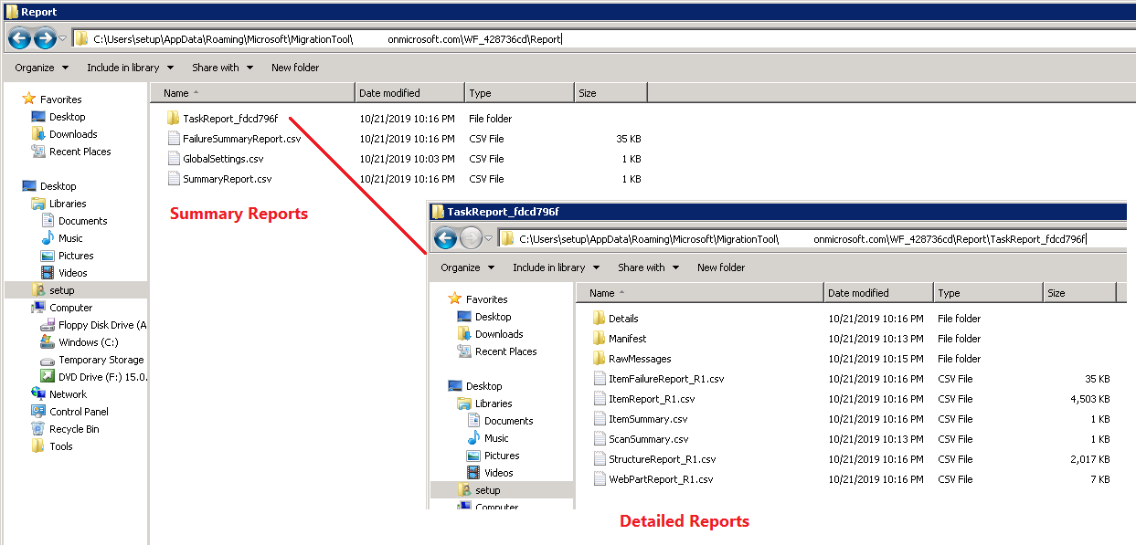

The SPMT reports can also be accessed directly at this default location: "C:\Users\<user>\AppData\Roaming\Microsoft\MigrationTool\<target tenant name>\"

1. Review the **FailureSummaryReport**.csv and the **StructureReport**_**R1**.csv at a minimum. For larger reports view the data with Excel. Copy the reports (CSV Files) to a machine with Excel installed. From **Excel** click **File** then click **Open**. Browse to the location of the CSV file. On the **Text Import Wizard – Step 1 of 3** select **Delimited** and click **Next**. On the **Text Import Wizard – Step 2 of 3** check the box **Comma** and click **Finish**.
2. In Excel use the **Filter** option on specific columns, like “**Status**”, “**Result**” to view only failures.

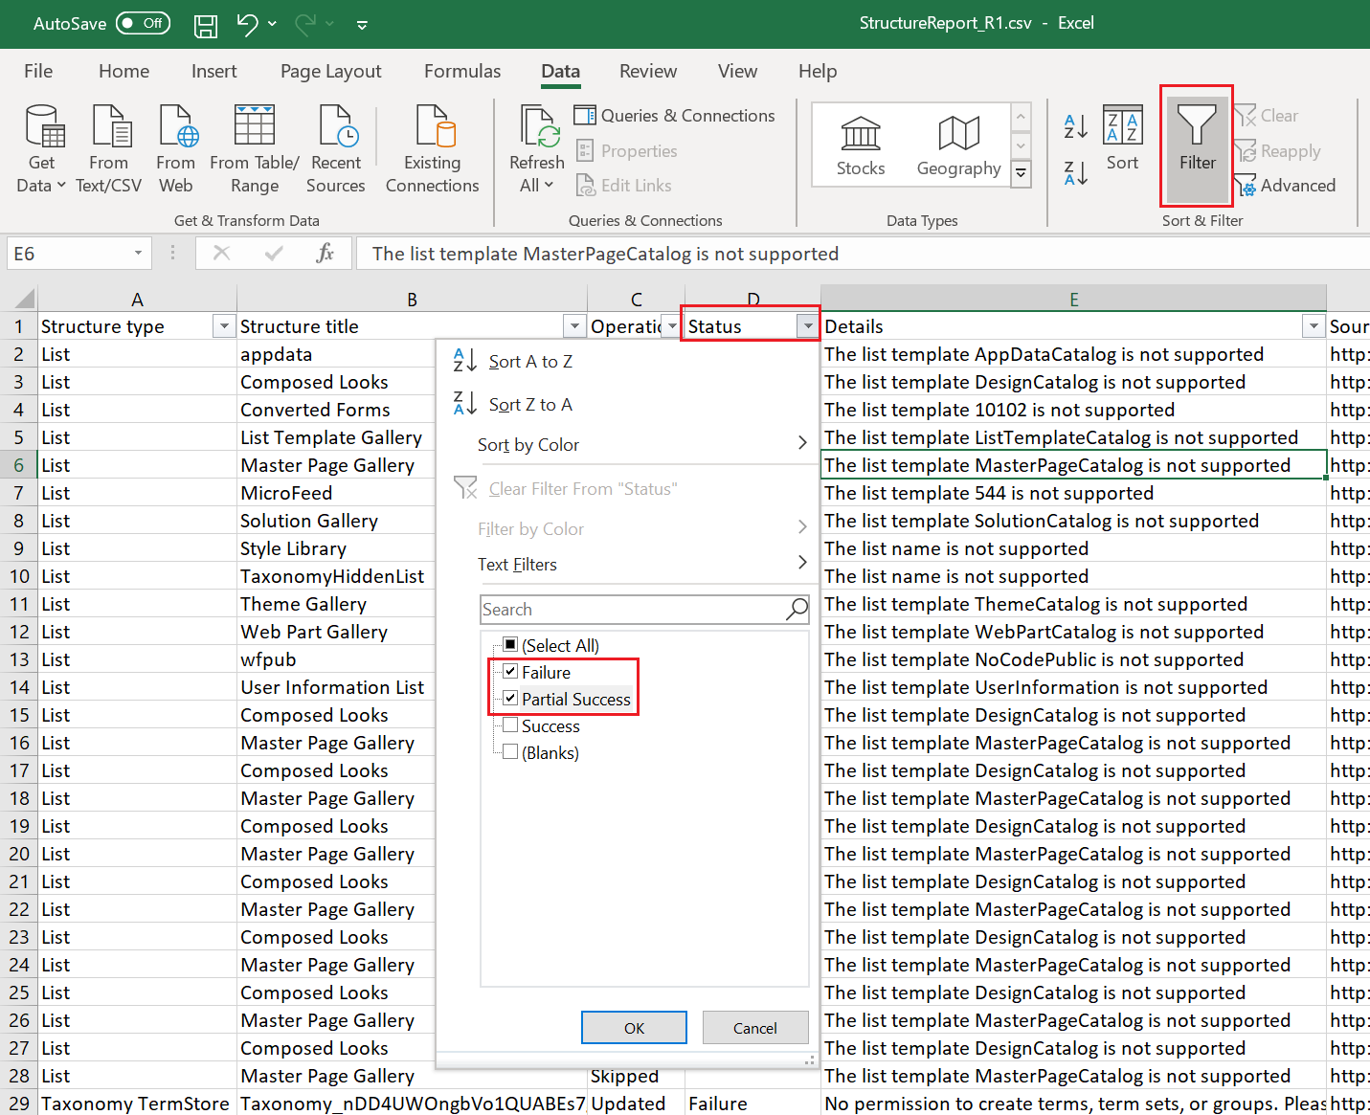

1. Open a browser and navigate to the source SharePoint server site and the target SharePoint Online site. Compare the **Site** **Contents** page from each site. The **Site** **Contents** page shows the libraries, lists, and subsites in the site. It may be easier to view the target SharePoint Online site in classic experience.

* **Source Site: SharePoint 2013 Team Site “/sites/training”**

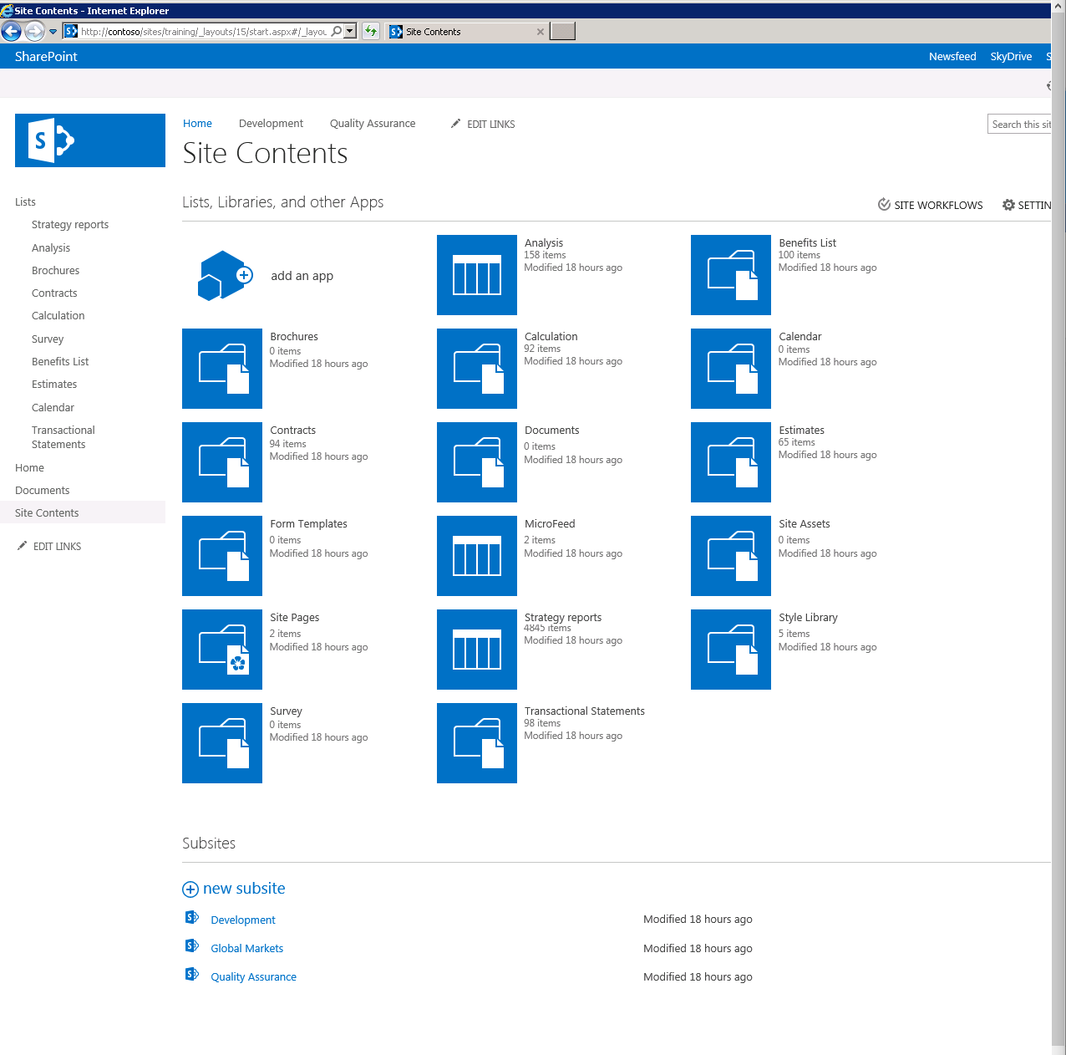

* **Target Site: SharePoint Online Site “/sites/trainingdepartment”** (Site Contents displayed in “classic experience” to demonstrate likeness.).

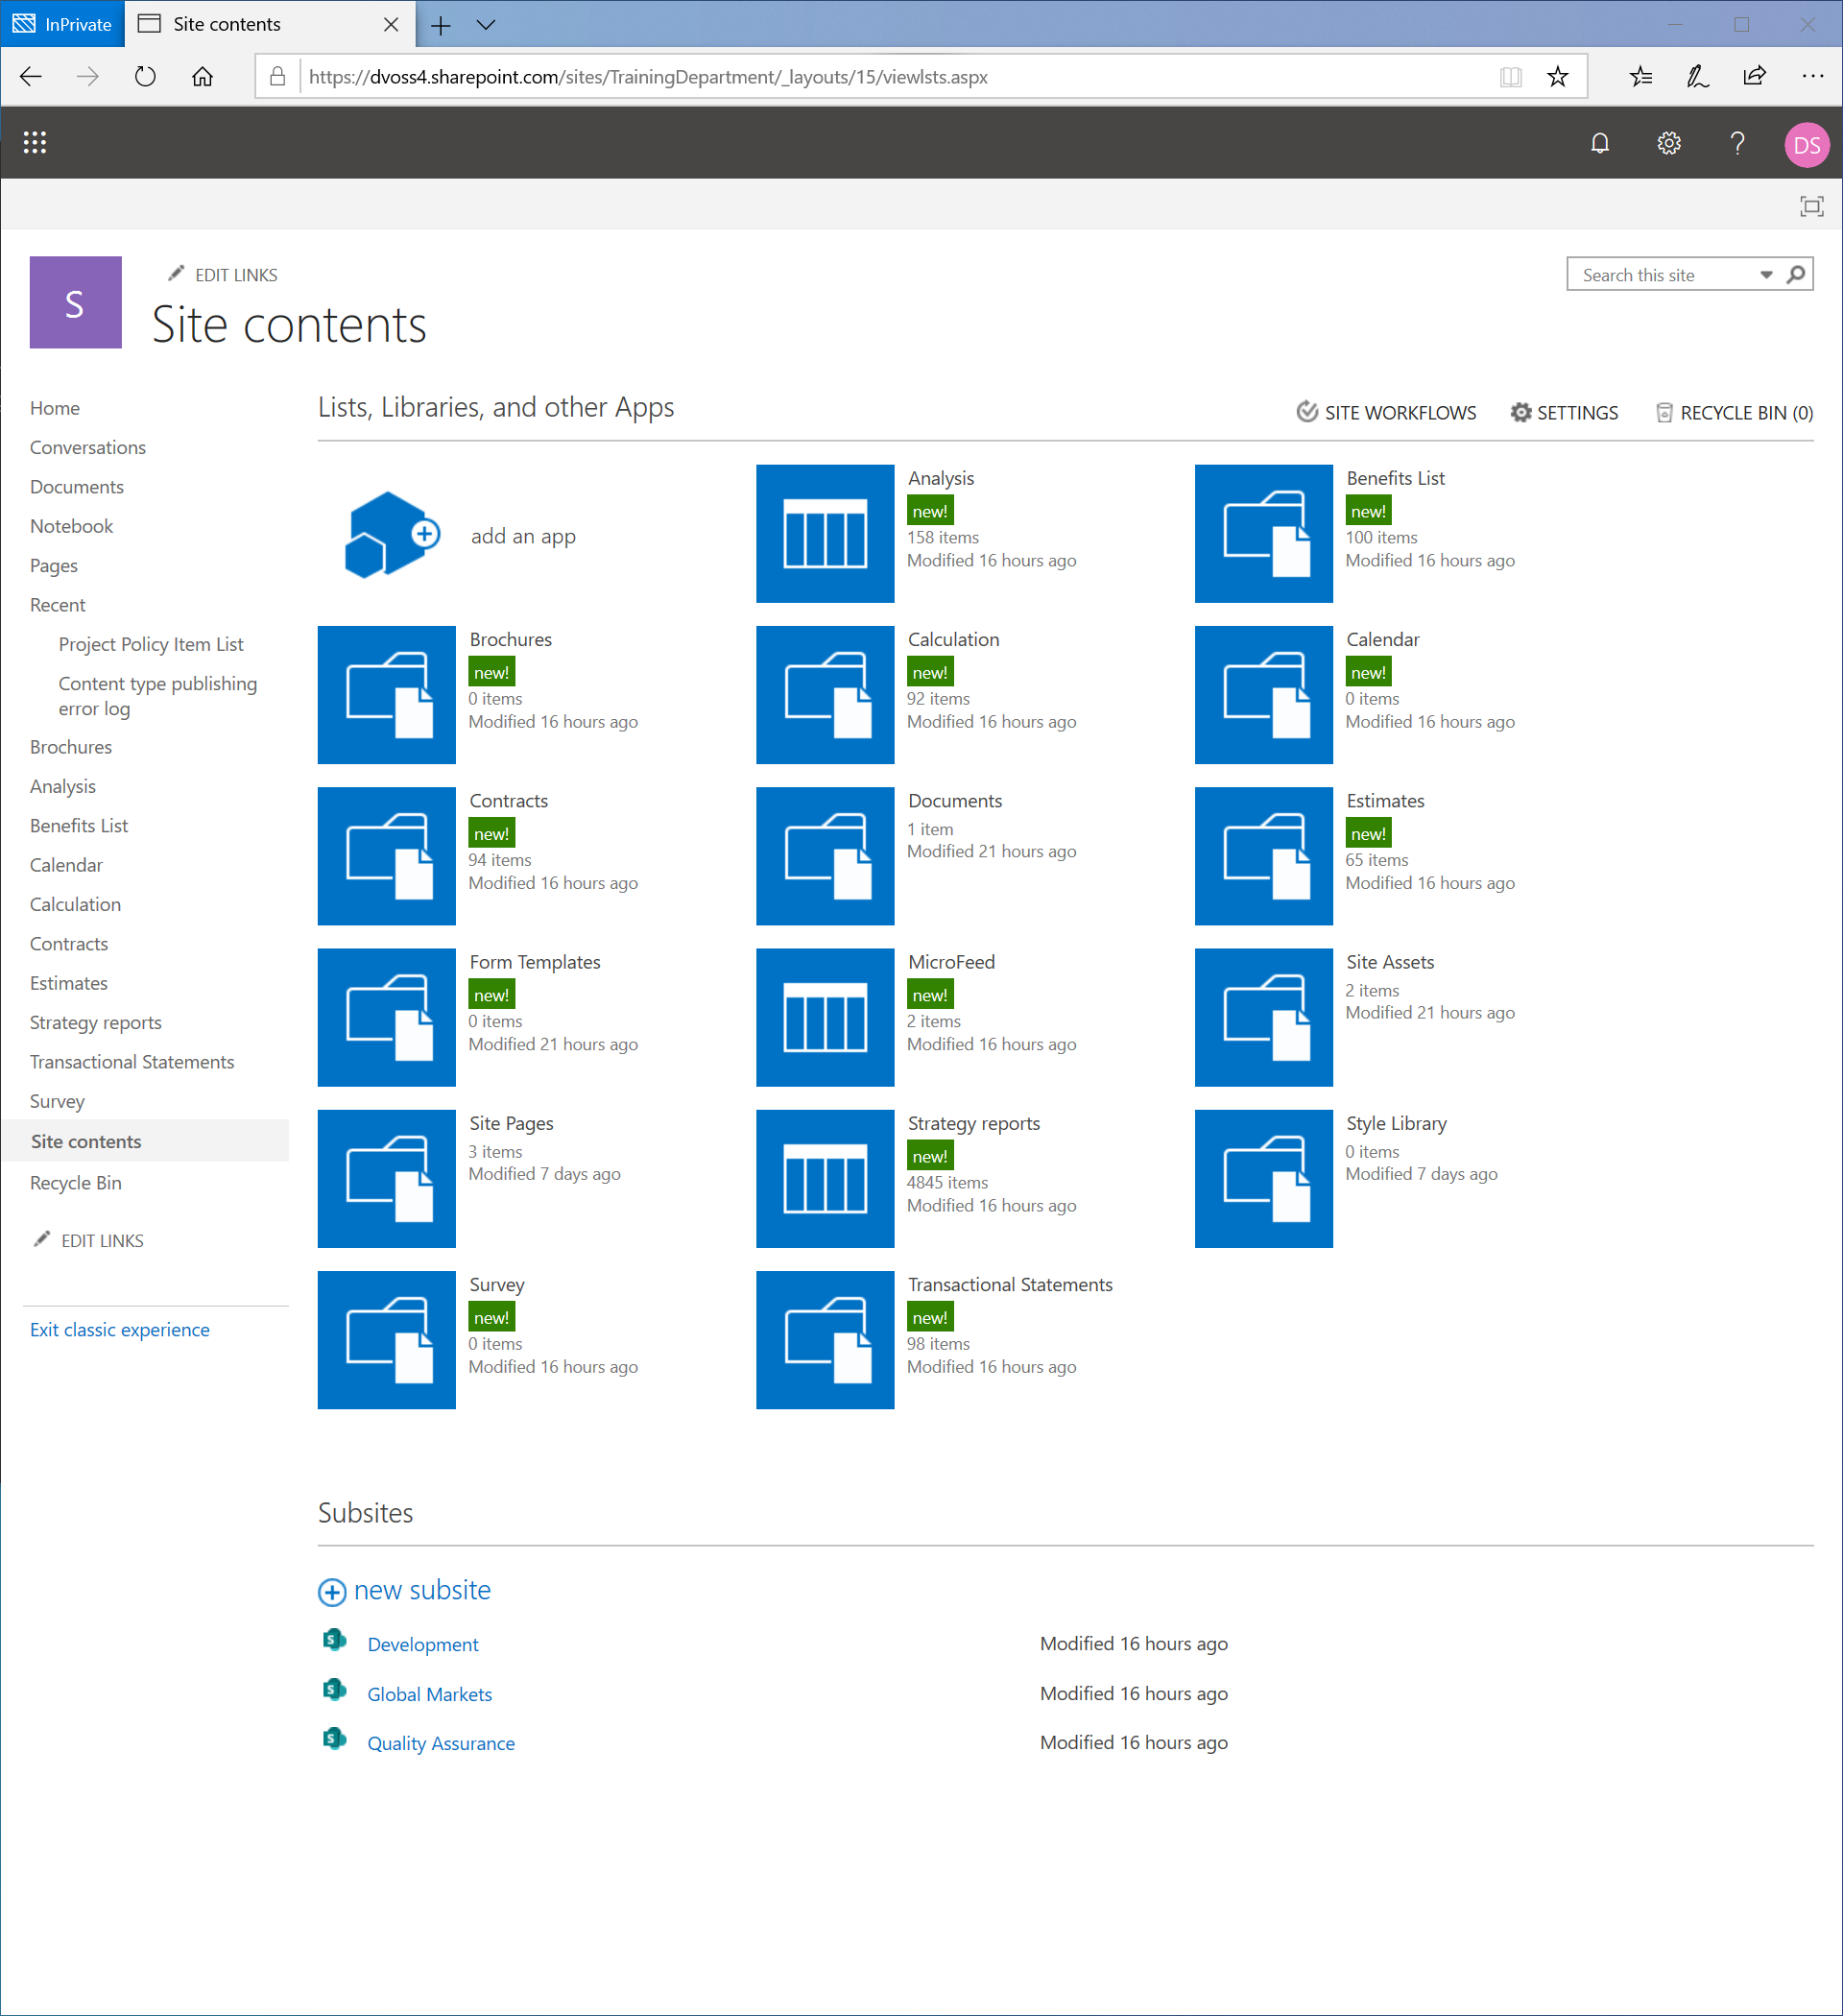

### Perform an incremental migration

Make changes to the SharePoint Server site and run an incremental migration using the SPMT tool.

1. Navigate to the source SharePoint Server site migrated in the previous step 4.1.2. (http://<hostname>/sites/<sitename). Click on the **Settings** gear icon then click **Site** **Contents**.
2. Click **add an app** then choose **Document** **Library**. In the **Adding Document Library** screen enter the name “**Incremental Migration Test**” and click **Create**. Upload some content to the library.

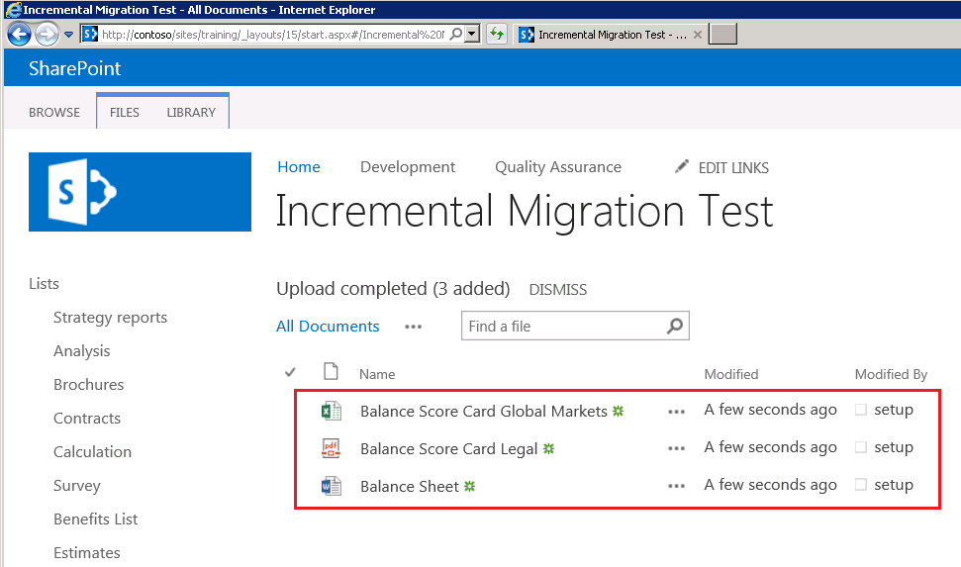

1. Log on to the migration machine and launch the **SharePoint** **Migration** **Tool**
2. In the **Sign-in to your account** prompt, enter credentials of an account with **SharePoint** **Administrator** or **Global** **Administrator** roles to the target Microsoft 365 tenant.
3. In the **Welcome Back to the SharePoint Migration Tool** screen click **Show saved migrations**

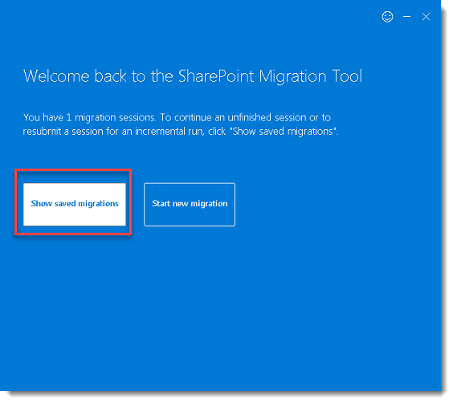

1. In the **Saved** **Migration** **sessions** screen locate the name of the migration you completed in the previous step andclick **Run incremental**

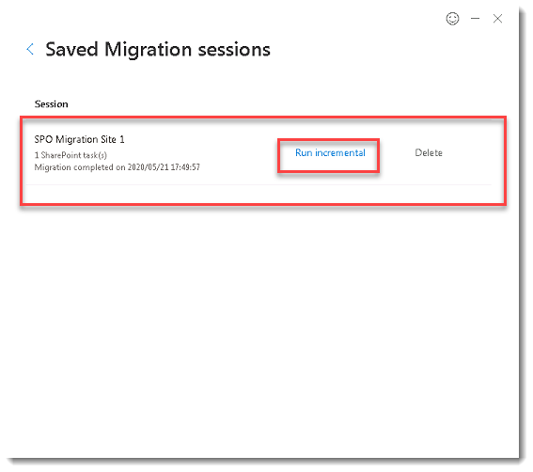

1. If prompted in the **Sign-in to the site below to authenticate** enter credentials of an account thathas access to the source SharePoint Server site.

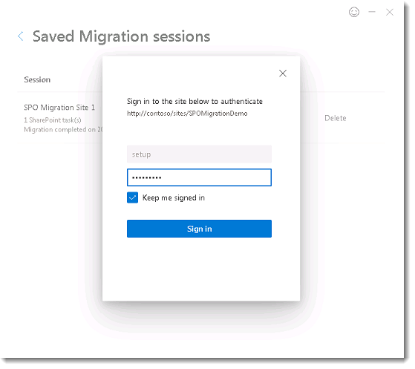

1. Confirm the migration was successful on the target SharePoint Online site by navigating to the document library.

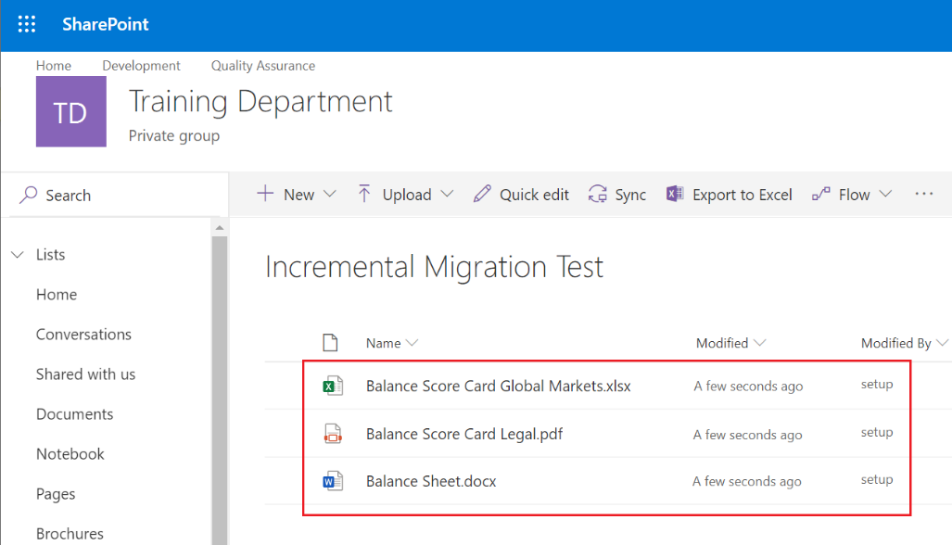

### Change configuration settings

Create a custom user mapping file, change configuration settings in the SPMT tool, and run a new migration.

#### Create a custom user mapping file

Create a custom the user mapping file and performing a new migration.

1. Navigate to a source SharePoint Server site (http://<hostname>/sites/<sitename). You can use the same site that was previously migrated in step 4.1.2 or a new site.
2. Click on the **Settings** gear then click **Site Settings**. Under **Users and Permissions** click on **Site Permissions**. Click the **Grant** **Permissions** button in the ribbon. Add one new user (that you know the password to) and one new Security Group to a SharePoint Group or Permission level with **Contribute**/**Edit** permissions.

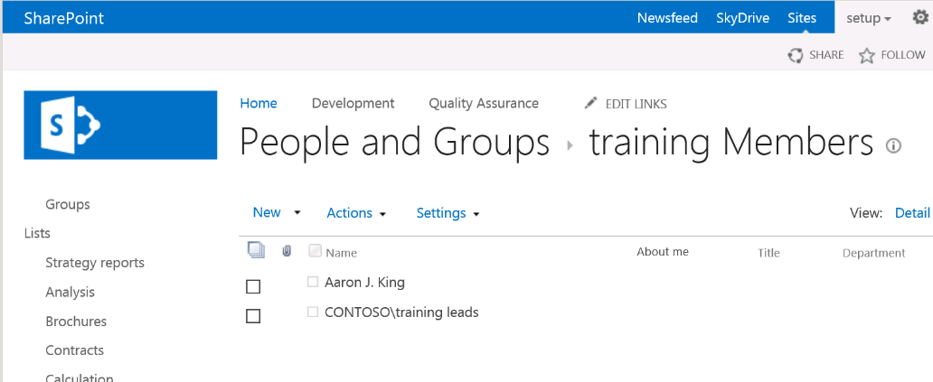

1. Sign into the site as the user added in the previous step. Upload or edit content in a document library. Note the name of the document library. The goal is to populate **metadata** on the new content, for example “**Modified** **By**” that displays the user’s name.

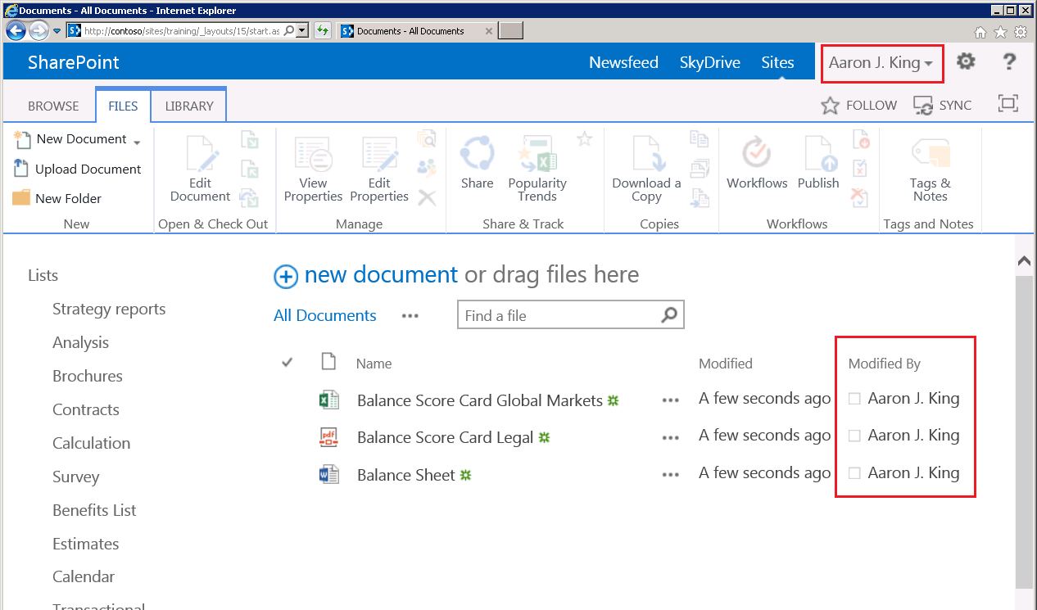

1. Locate the **SID** of the user account and group added to the site in the previous steps. Open the **Command Prompt**. If you are logged into the machine as the same user who uploaded content to the SharePoint site, run: "**whoami /user**". If you are not logged in as the same user, run "**wmic useraccount where name="**<enter name>" **get sid**".

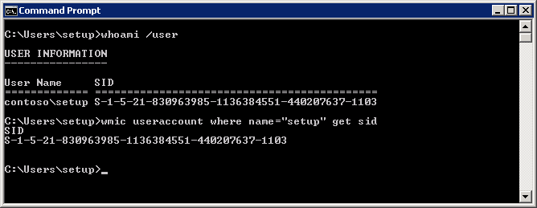

You can also use **PowerShell** cmdlets [Get-ADUser](https://docs.microsoft.com/en-us/powershell/module/activedirectory/get-aduser?view=winserver2012-ps) and [Get-ADGroup](https://docs.microsoft.com/en-us/powershell/module/addsadministration/get-adgroup?view=win10-ps) to export related properties from Active Directory, for example: *Note you will need the AD PowerShell addin.* [*ActiveDirectory Module | Microsoft Docs*](https://docs.microsoft.com/en-us/powershell/module/addsadministration/?view=win10-ps)

C:\PS>Get-ADUser <username> | Select UserPrincipalName,SID

C:\PS>Get-ADGroup <Name> | Select Name,SID

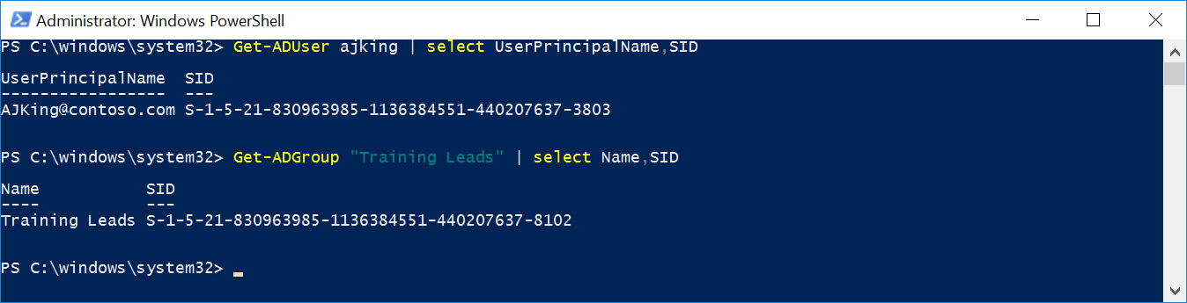

1. Identify the target user account and Security Group in Azure Active Directory that you will use to map permission to during the migration.
2. Start **Excel**.
3. Enter the values for your user mapping:

* **Column A:**
* Row 1: Enter the **SID** of the **User** from the source location.
* Row 2: Enter the **SID** of the **Group** from the source location.
* **Column B:**
* Row 1: Enter the **principal username** (email address format) of the target user in Azure AD
* Row 2: Enter the **Name** of the target Group in Azure AD.
* **Column C:**
* Row 1: Enter **FALSE**
* Row 2: Enter **TRUE**

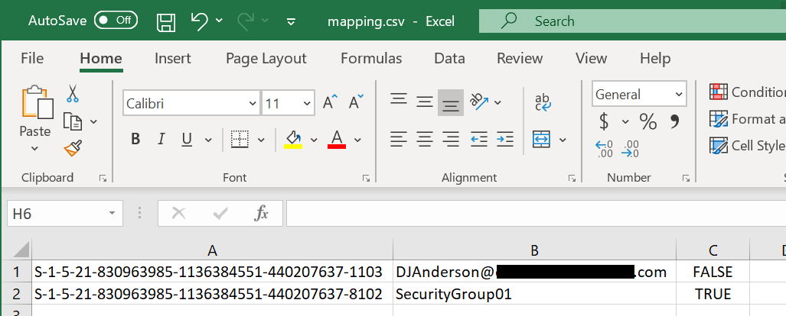

1. Close and **save as** a **Comma delimited (*.csv)** file. Copy the file to the migration machine.

#### Start a new migration with modified settings

Change the settings in the SPMT tool and perform a new migration.

1. From the migration machine launch the **SharePoint Migration Tool**
2. On the **Sign in to your account** prompt, enter credentials of an account with **Global Administrator** or **SharePoint** **Administrator** roles to the target O365 tenant
3. One the **Welcome** **to** **the** **SharePoint** **Migration** **Tool** screen click **Start** **a new** **migration**
4. On the **Where’s your content** screen select **SharePoint** **Server**.
5. On the **Select** **a** **source** screen enter the URL for the source SharePoint Server site. In the drop down select **Migrate** **all lists**, **libraries**, **and web parts**. Check the box to include all subsites (if needed). When prompted for authentication, enter the credentials of an account with Read permissions to the source site. Click **Next**.
6. On the **Where do you want to move it to** screen select **SharePoint team Site.**
7. On the **Select a destination** screen enter a new **URL** for the target SharePoint Online site. This should not be the same target site used in step 4.1.2.

You may get a warning about scripts being disabled you can click **OK.**

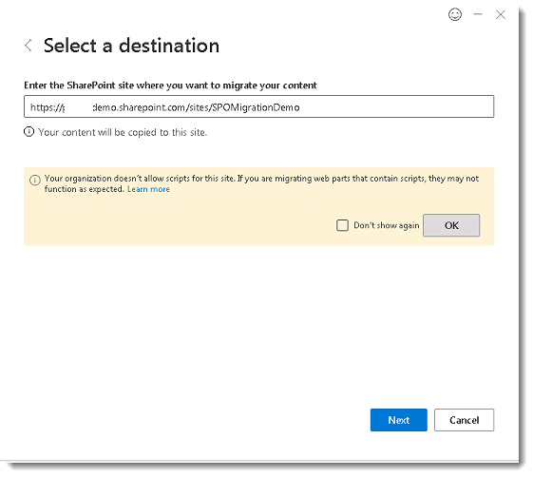

1. On the **Review migration** screen, click **Next**.
2. On the **Choose your setting** screen click **View all settings**
3. In the **All migration settings** screen click in the **User** **mapping** **file** box and click **choose** **file**. Browse to the user mapping file you copied to the migration machine in the previous steps.
4. In the **migrate** **files** **created** **after** select yesterday’s date.

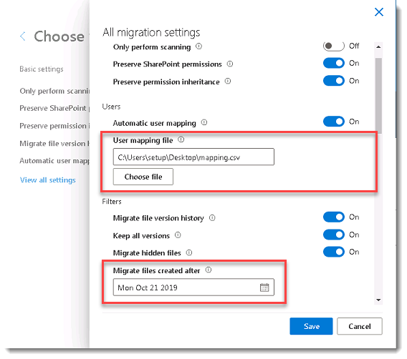

1. Scroll down until you see **SharePoint** **Migration** **Tool** **working** **folder**. Create a new folder on the migration machine. Click **choose** **folder** and browse to the folder you just created.

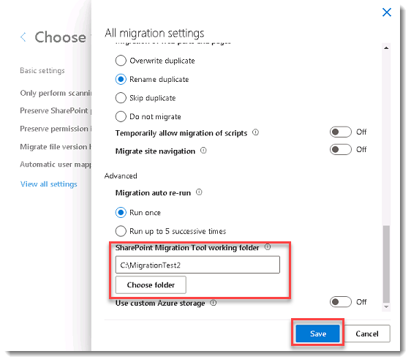

1. Review the other settings available in the **All migration settings** screen and click **Save**.
2. Back on the **Choose your settings** screen click **Migrate**.
3. On the **Migration completed** screen click **View** **Reports**. Notice the SPMT reports are stored in the new working folder location configured in previous steps, for example: "C:\MigrationTest2\MigrationTool\<target tenant name>". Also, there should be many "**item(s) filtered out"** because of the filter settings applied during the migration. Click **Save**.

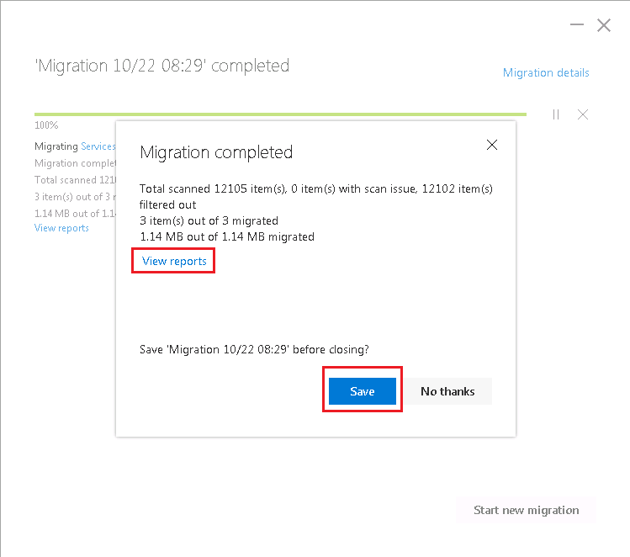

1. Browse to the target SharePoint Online site and confirm the following:
   1. Item counts should be very low because of the filter to only migrate files created after "yesterday": Navigate to **Site** **Contents** and confirm the number of **Items** in the lists and libraries.

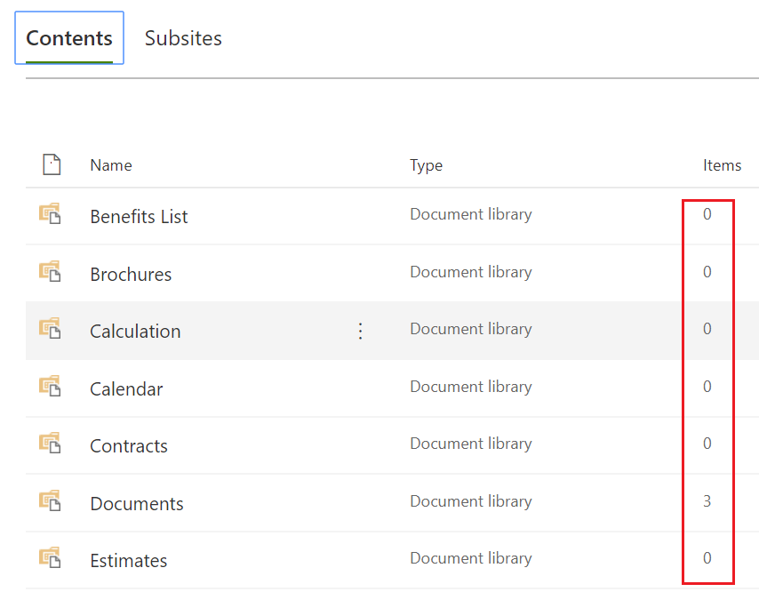

* 1. User identity mapping completed: Navigate to **Site** **Permissions** and click on the SharePoint Group that contains the mapped identities. Confirm you see the target **user account** and target **security group**.

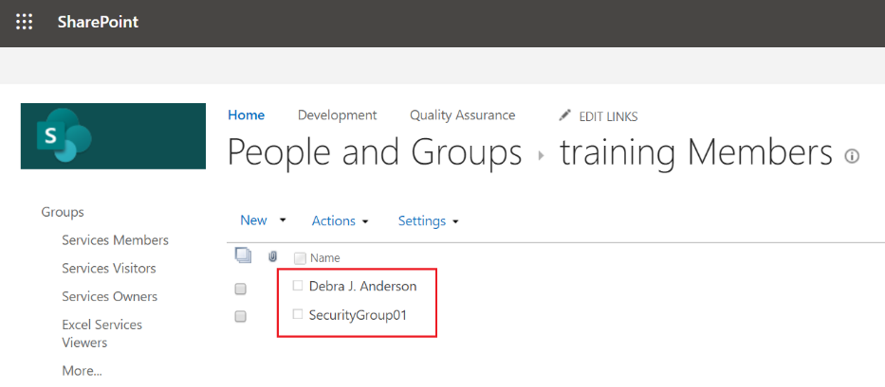

* 1. User metadata mapping completed: Navigate to the document library that contains the files added in the previous steps. Confirm the **metadata** of the user has been mapped to the new identity.

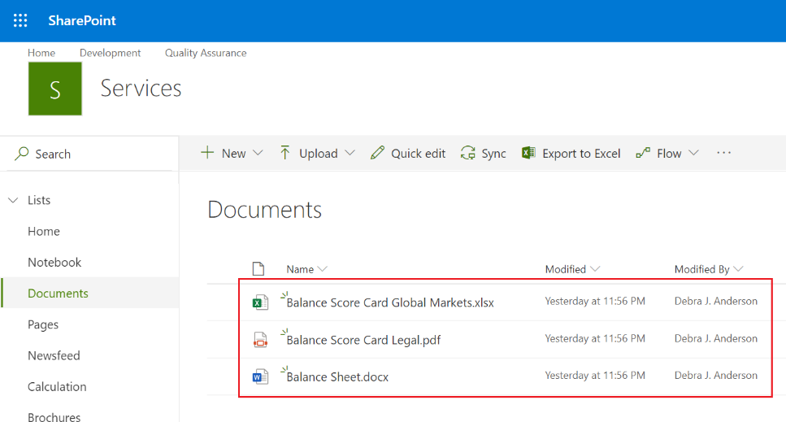

### Enable modern experiences on the migrated sites

Register, remove and manage hub sites using the SharePoint Admin portal in Microsoft 365.

#### Register a migrated site as a hub site using the SharePoint Admin portal

Register a new hub site using the SharePoint Admin portal in Microsoft 365.

1. Sign in to [https://admin.microsoft.com](https://admin.microsoft.com/) as a global or SharePoint admin. (If you see a message that you don't have permission to access the page, you don't have Microsoft 365 administrator permissions in your organization.)
2. In the left pane, under **Admin** **centers**, select **SharePoint**. (You might need to select Show all to see the list of admin centers.)
3. If the classic SharePoint admin center appears, select Open it now at the top of the page to open the new **SharePoint** **admin** **center**.
4. In the left pane of the new SharePoint admin center, select **Active** **sites**.
5. Select one of the migrated **sites,** click **Hub**, and then select **Register as hub site**.
6. Enter a display name for the hub site and specify the individual users or security groups you want to allow to associate sites with the hub, then click **Save**.

For more information, review **Create a hub site in SharePoint Online**: <https://docs.microsoft.com/en-us/sharepoint/create-hub-site>

#### Associate a migrated site to the new hub site using the SharePoint Admin Portal

Associate a migrated site to the new Hub Site registered in the previous steps using the SharePoint Admin Portal in Microsoft 365.

1. In the **SharePoint Admin center** select **Active** **sites**.
2. Select one of the other migrated **sites,** select **Associate with a Hub Site**.
3. In the **Hub Association** screen in the **Select a hub** drown click on the Hub Site you registered in the previous steps, then click Save.
4. Navigate to the **Hub** and **Associated** site to see the effects of the shared navigation.

#### Remove the hub site and association using the SharePoint Admin portal

Unregister a hub site and remove a site’s hub site association using the SharePoint Admin portal in Microsoft 365.

1. Select the site that youassociated with a Hub Site in the previous steps, click **Hub**, then select **Change hub association**.
2. In the **Hub Association** screen in the **Select a hub** drop down select **None**, then click **Save**.
3. Navigate to the **Associated** site to see the effects of the shared navigation being removed.
4. Select the site that youregistered as a Hub Site in the previous steps, click **Hub**, then select **Unregister as hub site**.

Hub Sites can also be managed using PowerShell, for more information see: **Create SharePoint hub sites by using PowerShell**: <https://docs.microsoft.com/en-us/sharepoint/dev/features/hub-site/create-hub-site-with-powershell>

#### Connect a migrated site to a new Microsoft 365 Group

Learn how to connect a recently migrated site to a new Microsoft 365 Group.

1. Browse to one of the new SharePoint Online sites created in this scenario. Click on the **Settings** gear in the top right. Then click on **Connect to new Microsoft 365 Group**

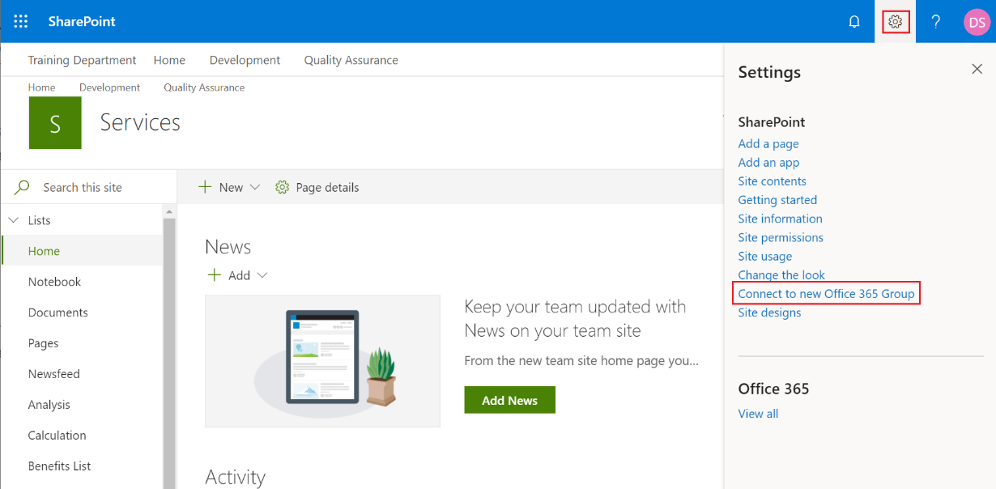

1. In the **Associate this team site to a new Microsoft 365 Group** window, click **let’s get started**.
2. Enter a unique **Group Name** and click on **Connect Group**.
3. In the **Add and assign people** screen, add additional owners and members (or not), then click **Finish**.
4. Demonstrate the new collaborations features unlocked by connect to a new Microsoft 365 Group using the **Outlook App** in the browser.

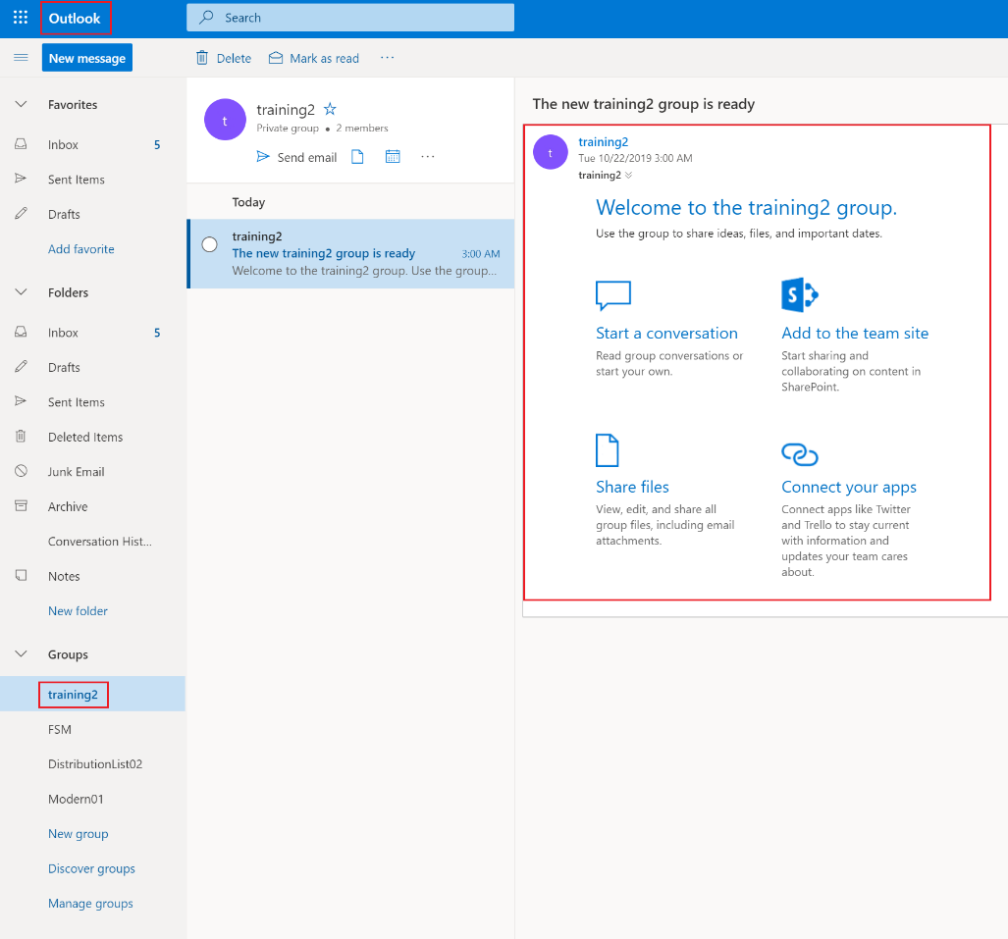

### Perform a bulk migration using a CSV file and the SPMT GUI

Perform a bulk migration of data using a using a comma separated (CSV) file and SPMT tool GUI. Utilize the bulk migration feature to migrate multiple source folders to different target libraries/folders in SharePoint Online.

**Note**: The SPMT GUI supports migrating content down to the library/list-level. The SPMT bulk migration approach supports migrating content down to the sub folder-level.

The goal of this exercise is to demonstrate the following concepts:

* Bulk migration using CSV file and SPMT GUI
* Folder-level migration
* Restructuring content during migration

#### Prepare the source SharePoint Server site with sub folders and content

Add folders and some content to a source SharePoint Server site which will later be migrated to a target SharePoint Online site using a bulk migration.

1. Browse to the source SharePoint Server site. Click on the **Settings** gear then click **Site** **Contents**. Click **Add an app** and select **Document Library**. Give it a tile and click **Create**.
2. Create 3 top-level folders named **FolderA**, **FolderB**, and **FolderC**.

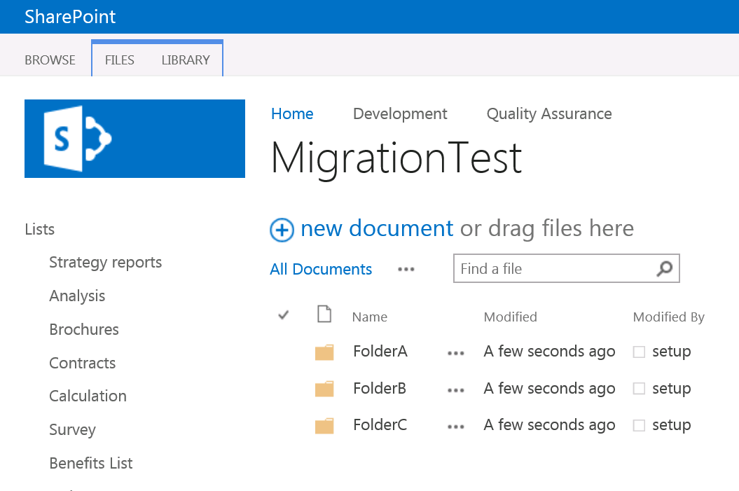

1. Add some unique documents to each folder.

#### Create a CSV file for content migration

Use any text editor, or an application like Excel, to create the CSV file.

1. Start **Excel**. Enter the values for your migration jobs. Enter one migration source and destination per row.
2. Add **three rows** of values.

**Note**: Do not include a **header row** in your CSV file. Remember to account for all six columns in the file, even if you are not needing a value for a given field.

1. See the reference table below for further explanation of **columns**:

* **Column A**:Enter the URL to the source SharePoint Server site that you added content to in the previous steps. Use the same URL for all three rows.
* **Column B**:Enter name of the source SharePoint Server document library you created in the previous steps. Use the same document library name for all three rows.
* **Column C**: Enter the name of one of the subfolders created in the previous steps.
* **Column D**:Enter the URL of the target SharePoint Online site. This can be a new or existing site.
* **Column E**: Enter the name of the document library in the target SharePoint Online site where the files are to be migrated. This can be a new or existing document library. Use a different library for each source folder.
* **Column F**:Enter the name of the target subfolder in the document library. If this column is left empty, the files will be moved to the root level. Leave at least one target subfolder value blank to see the content moved to the root level of a library.

1. Close and save as a **Comma delimited (*.csv)** file.

Example:

http://contoso/sites/training,MigrationTest,FolderA,https://yourtenant.sharepoint.com/sites/training,Resources,FolderA

http://contoso/sites/training,MigrationTest,FolderB,https://yourtenant.sharepoint.com/sites/training,Guides,FolderB

http://contoso/sites/training,MigrationTest,FolderC,https://yourtenant.sharepoint.com/sites/training,Archive,

#### Use the SPMT tool to migrate content using a CSV file

Migrate the content added in the previous steps to SharePoint Online using the SPMT tool and a CSV file.

1. Log onto the migration machine and launch the SPMT tool
2. On the **Welcome** screen click on **Start a new migration**.
3. On the Click on **JSON or CSV file for bulk migration**

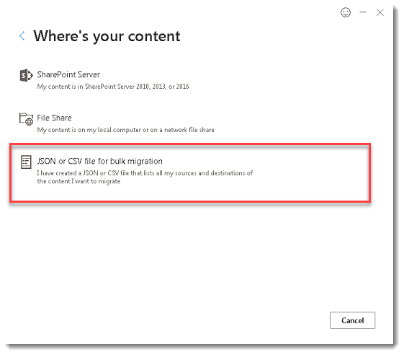

1. On the **Select a JSON or CSV for bulk migration** screen enter the full path of your .CSV file then click **Add**.

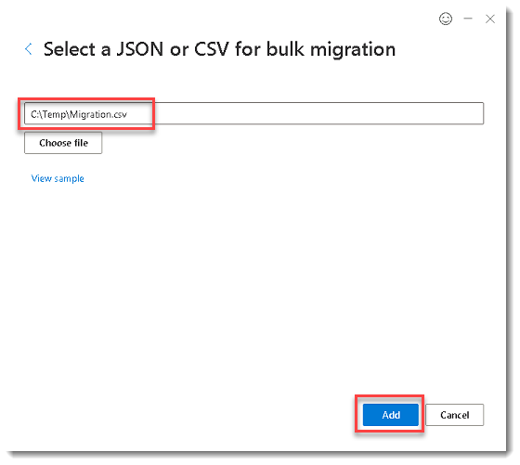

1. On the **Sign in to the site below to authenticate** prompt enter credentials of an account that has full read access to the source SharePoint Server site, check the box **Use one credential for bulk migration**, then click **Sign in**.

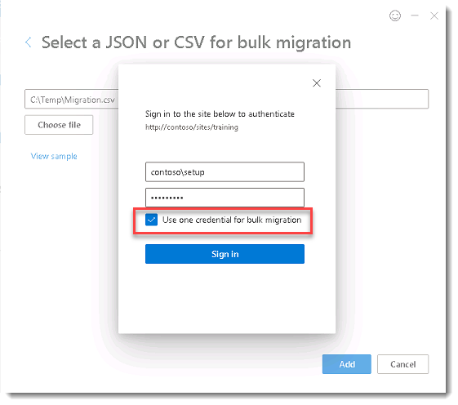

1. On the **Review migration** screen confirm you see the three jobs referenced in the CSV file, then click **Next**.

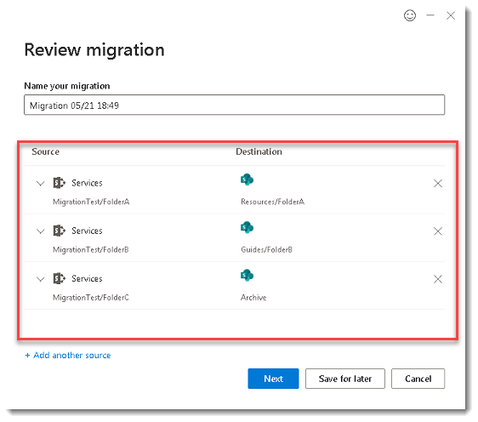

1. On the **Choose your settings** screen click **View all settings**. In the **All migration settings** popup remove the **User mapping file** and the filter **Migrate files created after** (which were settings used in the previous migrations), then click **Save**.

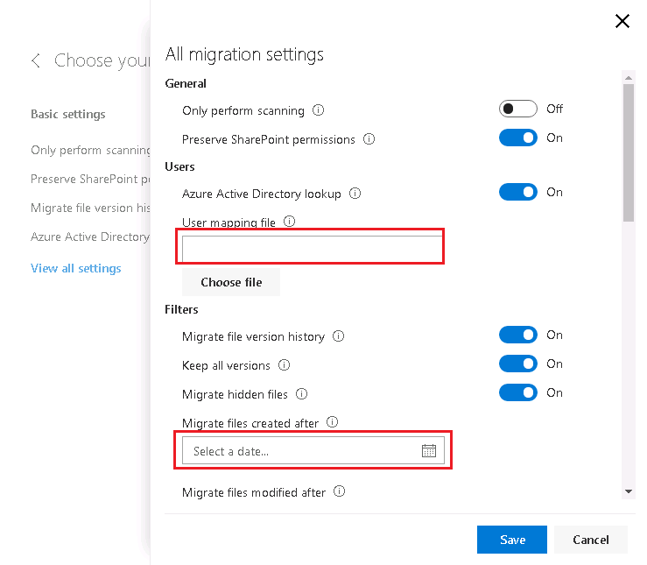

1. Back on the **Choose your settings** screen click **Migrate**.
2. Observe the migration progress. When completed, click **Save**.

|  |  |
| --- | --- |
| Screen capture of the SharePoint Migration Tool screen of the progress of the migration. | Screen capture of the SharePoint Migration Tool screen of a completed migration. |

1. Navigate to the target SharePoint Online site and look at the new document libraries that contain the migrated content.

